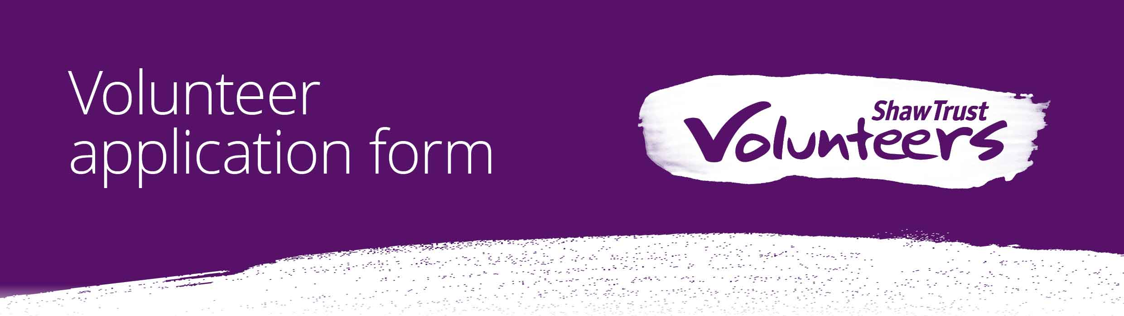

Hard copies of this form may be downloaded from our website
www.shaw-trust.org.uk or requested from volunteers@shaw-trust.org.uk

____________________________________________

From 25th – 27th October 2016, Edinburgh hosts the 23rd Rehabilitation International (RI) World Congress. Shaw Trust is organising this event on behalf of RI.

Over 1000 delegates from around the world are expected to attend the conference, many of whom may be disabled people.

We have a two rewarding volunteer roles available over the duration of the conference including:

Travel Buddies

You will ensure that the delegates’ journey from their arrival point into the city to the Edinburgh International Conference Centre or hotel is as smooth as possible.

Conference Assistants

Where you will contribute towards the overall experience of our visitors and ensure their needs are met over the duration of the event.

How to apply

Please complete this application form and return it to us. We will then contact you by phone to discuss your application in more detail.

What we look for
Volunteers at Shaw Trust come from a range of backgrounds. We look for certain attributes in all our volunteers that match our vision. These are detailed in the table below and are assessed throughout our application process.

Competency | Travel Buddy | Conference Assistant
A strong local knowledge of Edinburgh and its attractions or the ability to translate information confidently to delegates. |  | 
The ability to offer a warm welcome to guests and provide excellent customer service. |  | 
Excellent interpersonal skills and communication skills and the ability to confidently signpost delegates. |  | 
Neat and professional personal presentation |  | 
Fluent spoken English |  | 
A professional manner and the confidence to work independently. |  | 
A ‘can do’ attitude. |  | 
Good knowledge of the local area around Edinburgh Airport, Haymarket and Waverley train stations and the ability to support delegates to plan further travel. | 
An understanding and knowledge of Edinburgh City public transport. | 
A good working knowledge of Edinburgh City Centre, including around the EICC. | 
The ability to comfortably spend a number of hours out doors in seasonal weather and accompany delegates between their arrival point and EICC or hotel | 

Personal Details

Surname | Click here to enter text.
Forename | Click here to enter text.
Address | Click here to enter text.
Email | Click here to enter text.
Date of birth | Click here to enter text. |  | Please note you need to be over 18 to do some of our volunteer roles.
Telephone | Home | Click here to enter text. | Mobile | Click here to enter text.

Please specify the days/times that you will be available to volunteer. We would ask volunteers to commit to a minimum of eight hours w/c Monday 24th October in addition to time set for training. We will try to accommodate your preferences where possible.

Day | AM | PM | Evening
Monday 24th October | ☐ | ☐ | ☐
Tuesday 25th October | ☐ | ☐ | ☐
Wednesday 26th October | ☐ | ☐ | ☐
Thursday 27th October | ☐ | ☐ | ☐
Friday 28th October | ☐ | ☐ | ☐

To help us match you to a suitable role, please tell us if you are currently:
Employed full time | ☐
Employed part time | ☐
On a career break | ☐
Studying full time | ☐
Retired | ☐
Semi-retired | ☐
Unemployed | ☐
Other (please specify) | Click here to enter text.

Your skills and interests

Why do you want to volunteer for Shaw Trust and the 23rd Rehabilitation International (RI) World Congress?

Click here to enter text.
What area(s) of the event would you like to volunteer in?

☐ | Travel Buddy
☐ | Conference Assistant
☐ | Both
Please tell us about the skills/knowledge or experience you have in the areas you ticked above:

Click here to enter text.
Please provide details of any relevant training or qualifications:

Click here to enter text.

If you have volunteered or worked for the Shaw Trust before, please provide dates, location and name of your supervisor:

Click here to enter text.

Shaw Trust actively supports volunteers who have a disability. Please let us know if we can support you with this.

Do you consider yourself as disabled?
☐Yes
☐No

If yes, please let us know what support, if any, we can provide:

Click here to enter text.

How you heard about us

Please let us know how you found out about volunteering at Shaw Trust:

Click here to enter text.

Declaration

Please note all our volunteer roles where you will be supporting clients directly are subject to an enhanced DBS check. If you have any unspent convictions please tick the box below and include any details on a separate sheet and submit with this form. Any convictions do not necessarily exclude you from volunteering with us and we assess this on a case-by-case basis once the DBS check has been returned.

If you have any unspent convictions, please tick here: ☐

Declaration of interests

To protect the reputation of Shaw Trust, its employees and agents from accusations of bias, partiality or favouritism and comply with the Bribery Act 2010 and Charities Act 1993, we ask for all volunteers to declare any relationship or prior engagement with the Trust. This could include family members working for the Trust, prior contractual engagement with us or a professional connection.

This does not exclude you from volunteering with us, but in the interests of openness, we would ask you to declare the details as per our declaration of interest policy.

If you think this might be the case, please tick here: ☐

The personal information contained in this form will be processed for the purposes of your volunteering with the Company and by completing the form you are giving your explicit consent for this processing to take place within the remit of the Data Protection Act 1998.

Shaw Trust takes the health and wellbeing of our clients, staff and volunteers seriously. By signing this form you are indicating that to the best of your knowledge, you are currently fit and healthy to do this volunteer role and will inform ST if this changes at any point whilst volunteering with the organisation.

Signature: Click here to enter text. Date: Click here to enter text.

Please note that there is no requirement for you to have an original signature on the form if you are emailing it back to us. In emailing the form we accept that you are declaring that the information contained within the application is correct and that you give your consent for us to process your personal information within the remit of the Data Protection Act 1998.

Please send the completed form to:

volunteers@shaw-trust.org.uk

OR

Shaw Trust
Ground Floor
1 Osborne Terrace
Edinburgh,
EH12 5HG

Thank you for your application.

